Data Science Final Project Report:

Diabetes Prediction Data Set Analysis

M. Ashura Langford
Student ID: 004001453
Math 014-04
Dr. Meenakshi Nerolu
Dec. 2nd, 2025

OBJECTIVE
Clean and analyze the data set to find which factor could be considered a prediction variable for diabetes.

INTRODUCTION
Diabetes is a rapidly growing global health crisis that can be characterized by persistently high blood glucose levels, which lead to severe cardiovascular, renal, and even neurological complications. Understanding the complex relationship between demographic, clinical, and lifestyle factors is essential to creating effective interventions for overall public health. This project focuses on conducting an Exploratory Data Analysis using the Diabetes Prediction Dataset uploaded by user Marshal Patel2558. This dataset contains about 10,000 entries across 21 columns, which encompass a wide array of health metrics and potential risk factors. The key variables for analysis include demographic information(ethnicity, sex, age), essential clinical indicators(HbA1c, Fasting Blood Glucose, BMI, Blood Pressure, and Cholesterol levels), and lifestyle factors(Physical Activity Level, smoking status, and alcohol consumption).
The main objective of this project is to thoughtfully explore the dataset, creating clear and insightful visualizations, while also exploring interesting patterns related to diabetes risk.
This project aims to look into the following questions:
- Which features appear most strongly associated with diabetes status (e.g., Age, BMI, Glucose, Family History, Activity Level)?
- Which demographic groups (by age, gender, ethnicity, or BMI category) show higher risk profiles?
  - How does the proportion of individuals in different BMI categories look across categories like sex, age, and ethnicity?
- How do lifestyle factors (alcohol use, activity level) relate to diabetes or prediabetes indicators?
- Are there combinations of risk factors that seem particularly important?
  - What findings were the most disappointing?
- How does the distribution of high-risk glucose categories (Pre-diabetes and Diabetes) evolve across BMI Categories as the population ages?
- How does the trade-off between the two primary cardiovascular risk factors(Blood Pressure and Cholesterol) differ between individuals with a normal glucose status versus those with diabetes?
METHODS
The methods used in this analysis began with cleaning the data and preprocessing it. To begin, an irrelevant column titled “Unnamed” was dropped, and the missing values in the “Alcohol Consumption” column were handled through mode imputation, replacing the 3,320 missing entries with the mode, which was “Moderate”. Following the cleaning, the data types of several categorical columns(Sex and Ethnicity) were optimized by converting them into category types. This clean dataset was then filtered, which created a subgroup of Black individuals who consumed alcohol.
The analysis then began with creating new categorical columns that would allow for better visualization: “Body Mass Index(BMI) Category”(binned into Normal Weight, Overweight, and Obese), “Glucose Control Status”(binned from HbA1c into Normal, Pre-diabetes, and Diabetes), “Age Group”(segmented into Young Adult, Middle-Aged, Senior, and Elderly), and “Fasting Blood Glucose Risk Level” (FBG_3_Risk_level; binned from Fasting Blood Glucose into Normal Range, Pre-Diabetes Risk, and Diabetes). These parameters were set based on clinical research that is used in diagnosing diabetes and obesity. For example, when outlining the parameters for the BMI and Glucose Control, I used information found from the NHF and CDC.

Table detailing parameters based on Age:
 | Young Adult | Middle-Aged | Senior | Elderly
Age | <30 | 30 to 50 | 50 to 65 | >65

Table detailing BMI parameters:
*Based on NHC Inform* | Underweight | Normal Weight | Overweight | Obese
BMI | <18.5 | 18.5 to 24.9 | 25 to 29.9 | >30

Table detailing Diabetes parameters based on HbA1c:
*Based on CDC* | Normal | Pre-Diabetes | Diabetes
HbA1c Levels | <5.7% | 5.7% to 6.4% | >6.5%

The final stage was exploration, using a mix of static and interactive visualizations, including Seaborn Heatmap, Violin Plot, Countplot, Histogram, Box Plot, Plotly Animated Stacked Box Plot, and Sunburst Plot. These visualizations allowed me to further explore and understand the dataset.

ANALYSIS & INTERPRETATIONS

- Which features appear most strongly associated with diabetes status (e.g., Age, BMI, Glucose, Family History, Activity Level)?
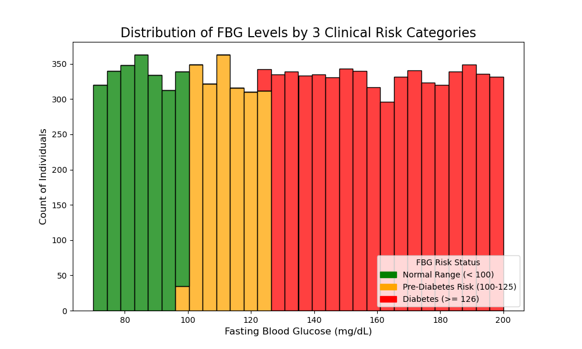
Based on the data, the most strongly associated features are the clinical measures for glucose control. Glucose metrics, such as HbA1c and Fasting Blood Glucose, showed that an overwhelming portion of the population has impaired glucose control, with 7,784 individuals within the Diabetes category based on their reported HbA1c and 5,671 individuals in the high-risk category based on their fasting blood glucose(refer to Fig.1).
Figure 1: A distribution of risk levels based on Fasting Blood Glucose. Slightly skewed towards the right due to majority of participants being within the diabetic risk(red).

- Which demographic groups (by age, gender, ethnicity, or BMI category) show higher risk profiles? How does the proportion of individuals in different BMI categories look across categories like sex, age, and ethnicity?
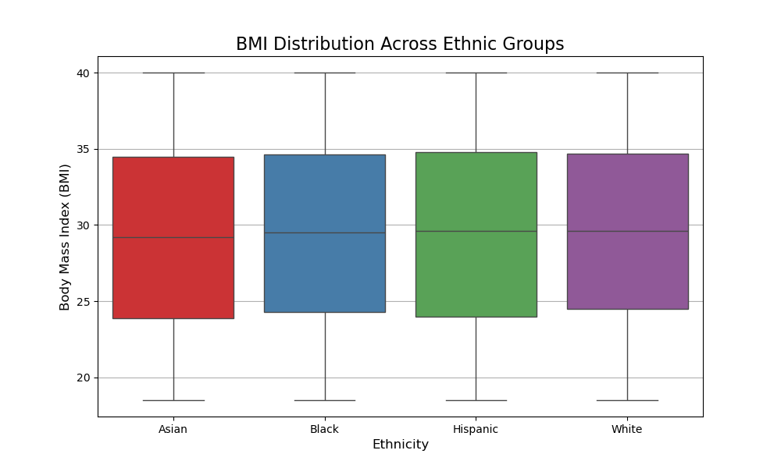
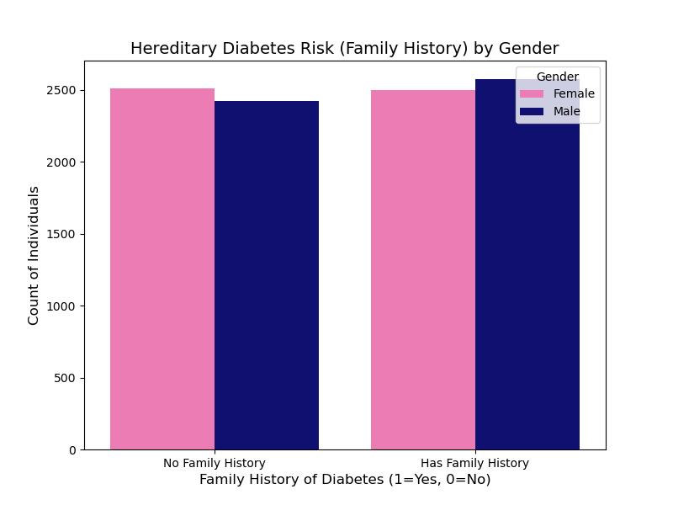
The dataset was dominated overall by the higher BMI categories, with the obese category containing the largest single count of 4,785. There were differences across the age groups. The most prominent high-risk group was the obese category, which, when aged was accounted for, showed that Middle-Aged(4,094) and Senior(2,985) age groups represented the greatest overall count of individuals within the diabetes status. There were no drastic differences in BMI across ethnic groups; however, the Hispanic groups had the highest median BMI(refer to Fig. 2). Obesity seems to be a significant issue across all ethnic groups. In the context of gender, males show a slightly greater predisposition to diabetes risk based on having a family history of diabetes(refer to Fig.3). There were no drastic differences in BMI across sex.
Figure 2: A distribution of BMI by ethnic group. There are no drastic differences.
Figure 3: A histogram comparing predisposition to diabetes based on gender. Males have a slightly higher risk to developing diabetes due to family history.

- How do lifestyle factors (alcohol use, activity level) relate to diabetes or prediabetes indicators?
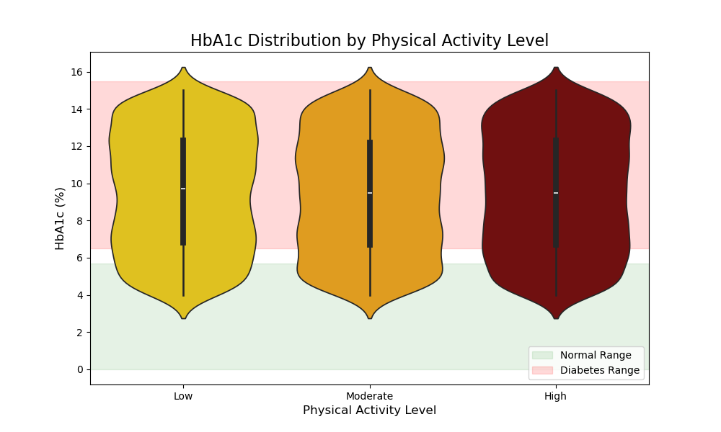
Based on Figure 4, there is somewhat of a relationship between the lower activity level and higher HbA1c levels. As there is a wider distribution of glucose values and a higher concentration in the diabetic range. This indicates that lower physical activity is associated with poorer glucose control, leading to a higher risk of developing diabetes. In reference to the alcohol consumption, due to the initial 3,320 missing values that were imputed with the mode of “Moderate”, there cannot be a proper analysis done, as the true reported alcohol assumption is not known for at least 30% of the participants. The imputation method only created an assumption.
Figure 4: Violin Plot for the distribution of HbA1c levels based on activity levels.
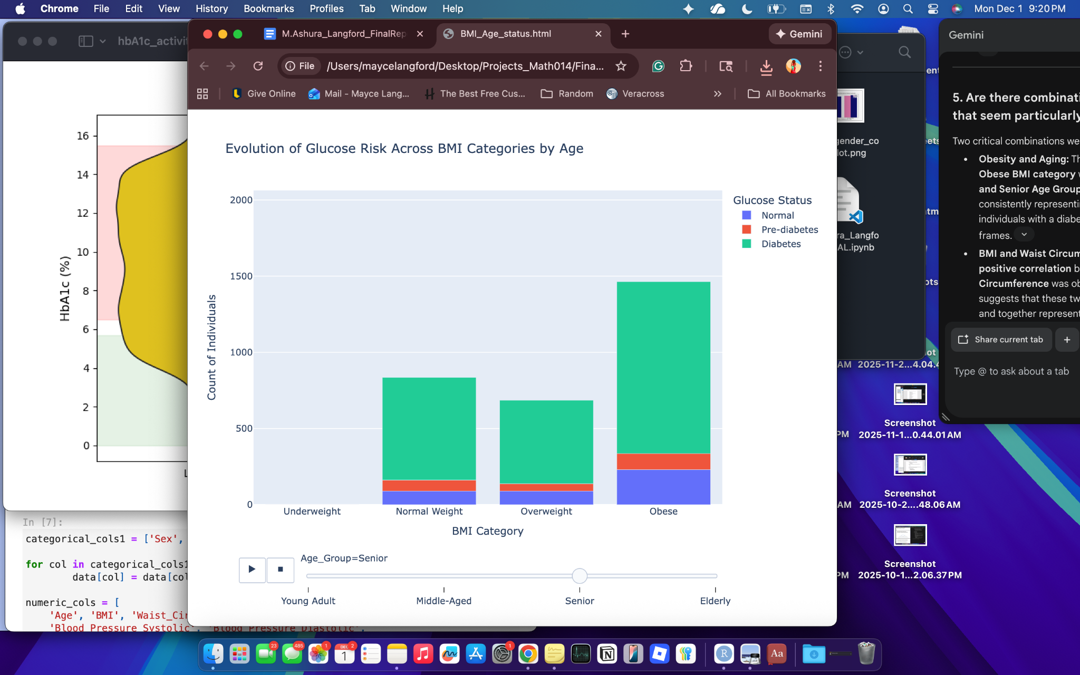
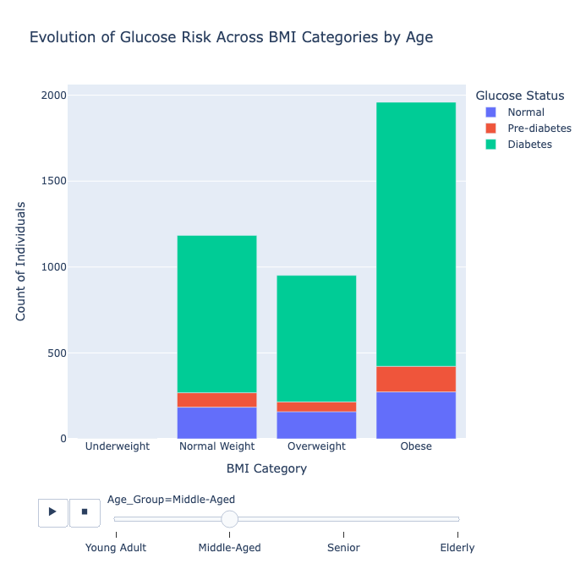
Figure 5: Two distributions based on age, BMI category, and glucose status. Senior age group can be seen on the left and the Middle Age group can be seen on the right.
Senior Distribution
Middle Age Distribution
- Are there combinations of risk factors that seem particularly important? How does the distribution of high-risk glucose categories (Pre-diabetes and Diabetes) evolve across BMI Categories as the population ages?
After analyzing the data, one critical combination was identified: Obesity and Aging. Similar to what was stated earlier, the combination of the Obese BMI category with the Middle-Age and Senior Age group consistently represents the highest count of people with diabetes across all age groups. This suggests that age could be a predictive factor for diabetes(refer to Fig. 5). The transition from middle-aged to senior, combined with high BMI, could put individuals at a higher risk of developing diabetes. Please note that obesity dominated across all age groups.
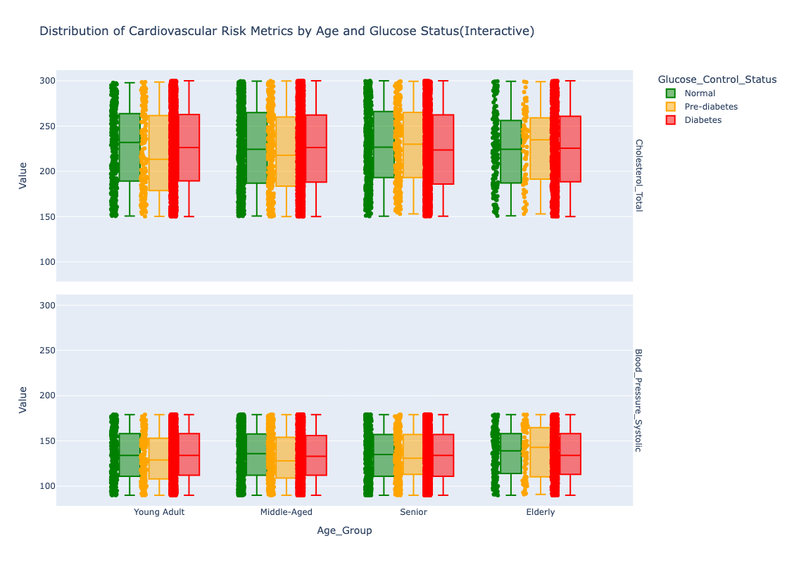
BMI and waist circumference showed a slightly negative correlation, but it was not significant enough for BMI to be a predictive factor for waist and vice versa(refer to Fig. 6).
Figure 7: The boxplots show the distribution of Cholesterol and Blood Pressure values across age groups and glucose status.
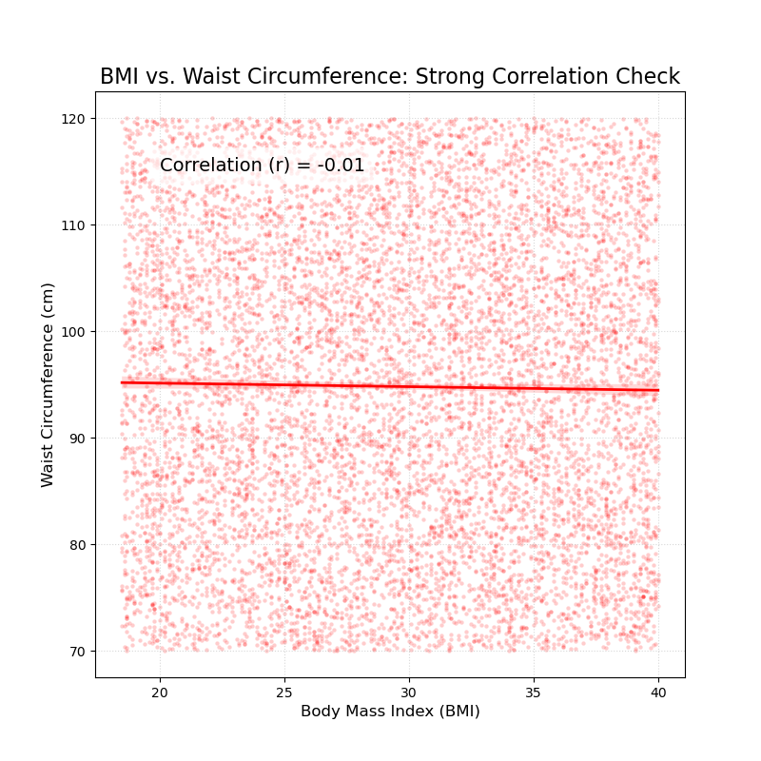
Figure 6: A scatterplot to check if waist and BMI are strongly related. This check failed as the correlation was about -0.01.

- How does the trade-off between the two primary cardiovascular risk factors(Blood Pressure and Cholesterol) differ between individuals with a normal glucose status versus those with diabetes?
The box plots highlight a severe trade-off showing that poorer glucose regulation is associated with elevated cardiovascular risk(refer to Fig. 7). The diabetes group exhibits a consistently higher median for Cholesterol Total and even higher medians for Blood Pressure Systolic when compared to the normal group. The differences in both cardiovascular measures are most prevalent when looking at the Normal group and comparing them to the Pre-diabetes and Diabetes groups across all ages. The position of the margin boxes shows that poor glucose regulation, regardless of age, increases the median cardiovascular risk.

LIMITATIONS AND FUTURE DIRECTIONS
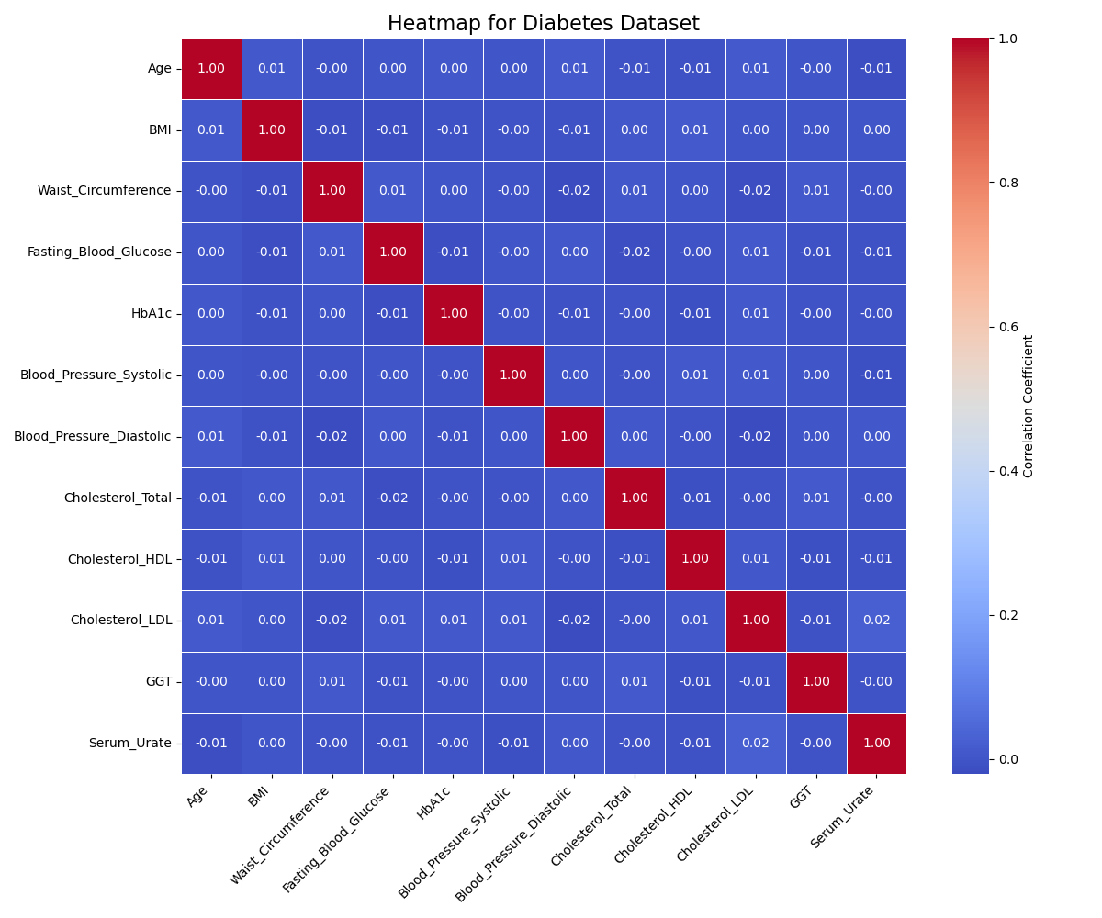
This analysis and dataset are subject to several inherent limitations, which should be considered before applying these findings to a political or clinical context. First, there is high sampling bias towards individuals with impaired glucose control, with almost all participants falling in the Diabetes category. This overrepresentation implies the sample is not reflective of the general population’s diabetes prevalence, which means there is potential for sampling bias. It could be that the study was advertised at a clinic with patients at high risk for diabetes, or there was selective participation. This could be fixed in the future by adding diversity in sample location(areas with different socioeconomic classes, states, etc) when boosting the study. Another limitation is the lack of several critical values for a comprehensive idea of diabetes management. There is an absence of data for medication adherence(whether they take medicine for diabetes) or dietary habits(beyond caloric intake); the absence of these key variables limits the ability to conclude treatment or lifestyle factors. Another limitation was the large amount of data missing from the “Alcohol Consumption” column, which led to mode imputation. This cleaning decision was done to preserve sample size, but it introduced more bias, which nullified the ability to create meaningful relationships. Finally, although clinical markers(FBG, HbA1c, etc) are likely measured, the reports on lifestyle choices (physical activity, smoking status, etc) are likely self-reported. This introduces reporting bias, where people may over-report positive or under-report negative behaviors, which can lead to measurement errors, thus hindering the analysis of the data.
Figure 8: A correlation matrix demonstrated in a heatmap for all numeric values in the Diabetes Prediction Dataset. All correlations are weak regardless of direction.
Based on the findings of the analysis, there isn’t sufficient evidence to provide any type of policy recommendations as there were overwhelmingly low correlations between most variables(refer to Fig. 8). However, the results when looking at BMI groups and age groups suggested that Middle-Aged and Senior individuals with higher BMI are at a higher risk of diabetes. Due to this, implementing policies that strongly target these high-risk groups would be effective. Public programs and campaigns should focus on culturally sensitive weight management and increased physical activity within these high-risk groups to decrease the progression of pre-diabetes to over diabetes. Increasing activity is essential as the low activity group showed the poorest glucose control.
Future analysis should specifically answer the research questions that remain unexplored:
- What role does smoking status play in increasing the risk of diabetes across age groups?
- Can high activity mitigate the risk of diabetes in individuals with higher body mass index?

CONCLUSION
This Exploratory Data Analysis of the Diabetes Prediction Dataset was successful in identifying critical risk patterns within the sample population, despite the dataset’s limitations. This analysis, however, failed to understand the strength and correlation of these risk patterns, so all discussion of findings is based on trends seen in the data. This analysis hypothesizes that age and body mass index, when combined, are a significant risk factor for developing diabetes. Furthermore, poor glucose regulation could be a possible predictor for higher cardiovascular risk, as the diabetes group demonstrated higher medians in Cholesterol and Blood Pressure. Low physical activity could also be associated with poorer glucose control. The lack of data points in the alcohol consumption led to the exclusion of the column from the overall analysis. In the end, while the results are not generalizable, the findings provide insight into the possible populations when creating public health interventions. These interventions should focus on weight management for the Middle-Aged and Senior population, along with integrated clinical screenings for cardiovascular issues regardless of glucose status.

ACKNOWLEDGEMENTS
Thank you to Dr Nerolu for supporting me throughout this semester and for helping me become a better researcher.

REFERENCES
American Diabetes Association Professional Practice Committee. (2022). 2. Classification and diagnosis of diabetes: Standards of medical care in diabetes—2022. Diabetes Care, 45(Supplement_1), S17–S38. https://doi.org/10.2337/dc22-S002
CDC. (2025, January 8). A1c test for diabetes and prediabetes. Diabetes. https://www.cdc.gov/diabetes/diabetes-testing/prediabetes-a1c-test.html
Checking your browser—reCAPTCHA. (n.d.). Retrieved December 1, 2025, from https://www.kaggle.com/datasets/marshalpatel3558/diabetes-prediction-dataset
How do i measure my body mass index (Bmi)? (n.d.). NHS Inform. Retrieved December 1, 2025, from https://www.nhsinform.scot/healthy-living/weight-loss/understanding-healthy-weight/how-do-i-measure-my-body-mass-index-bmi/

